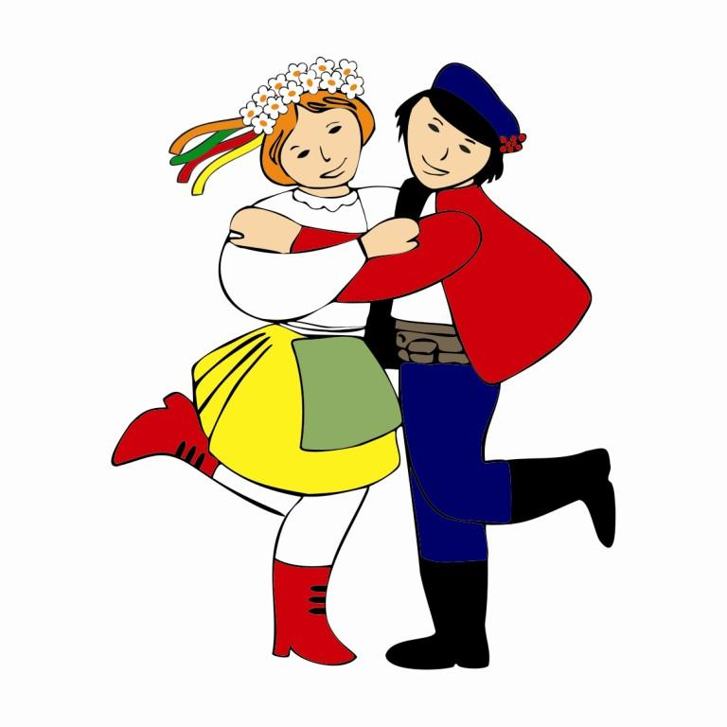
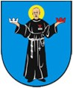
ZDUŃSKA WOLA DISTRICT

TERMS AND REGULATIONS
9th International Festival
„Folklore of the World”
29.06.2018 – 01.07.2018

- The International Festival „Folklore of the World” is organized annually and takes place in Zduńska Wola at the first weekend of July.
- We invite to participate in a festival children and youth amateur dance teams, groups operating at schools, cultural and educational institutions
- The number of members of the group cannot exceed 35 people (including: band, dancers, singers, group supervisors, drivers, companions etc.).
- In order to take part in the festival, each group has to pay an entry fee – the amount of 100 PLN per each participant (including: band, dancers, singers, group supervisors, drivers, companions etc.). This fee should be transferred bank account:

Stowarzyszenie Kulturalno-Sportowe „Talent”
ul. Kilińskiego 17, 98-220 Zduńska Wola
bank account number: 59 1600 1462 1818 4649 5000 0001
with a title „Folklore of the World”

- Festival participants cannot belong to more than one registered group
- Groups cover all the expenses of travelling to the place of the festival.
- Event organizer provides:
- accomodation;
- 3 meals per day;
- one guide for each group which comes from abroad (polish groups can also receive one if they report in advance such a need to the organizer)
- Event organizer does not cover costs of transport and insurance. Every group member must be insured (group and individual insurance). The insurance must cover the costs of medical treatment in Poland. Each leader of the group is responsible for completing this requirement.
- During the festival group leader is fully responsible for their group, especially for:
  - punctuality to follow the festival schedule properly
  - friendly attitude to other groups and staff.
- During the accommodation process, each group pays the deposit – 10 PLN per each group member to cover all possible damages made in the place of staying. The deposit will be returned after checking rooms an returning keys on the departure day in the full amount or will be reduced by the cost of potential damages.
- Event organizer is not responsible for things left in changing rooms and presentation places.
- Event organizer reserves the rights to change the terms and regulations of the festival.
- Event organizer reserves the rights to document and use group presentations in press, radio, TV and on the website without paying any fees to participants.
- Groups must take part in all events during the festival.
- During the opening ceremony of the festival, each group should make a short presentation (not longer than 5 minutes).

- Filled registration card with a copy of bank transfer and attachments as follows :
- short information about the group and their achievements,
- full list of group members (with a date of birth and a team function)
should be sent to the event organizer by e-mail until 31 May 2018

Stowarzyszenie Kulturalno-Sportowe „Talent”
ul. Kilińskiego 17, 98-220 Zduńska Wola
e-mail: centrum.pieterko@gmail.com

- Sending the registration card is considered as the acceptance of the terms and regulations of the festival. Be noted that only 25 groups can take part in the festival. The entries should be sent only by email. The participation in the festival is based on the order of sending registration cards.
- Groups will be rated in 2 categories
1st - group with members up to 15 years old -
2nd - group with members older than 15
The age of the majority of participants determines the qualification for one given category (according to the current list sent by the team before or on the day of 31st of May 2018)
- Every qualified group need to prepare 2 different artistic programs lasting 10 minutes each (with 3 minute tolerance) /first for a presentation during festival, second one for the jury’s request/, and a presentation during musical procession through the streets of Zduńska Wola which will take place on the first day of the festival. This presentation should last 3 to 5 minutes This presentation should last 3 to 5 minutes
- Every presentation should have live music accompaniment or accompaniment from CD. The musical and instrumental composition of the band is not a subject of evaluation
- The jury consists of representatives of each group with the leader who will be chosen by the the authority in folk dancing and singing, chosen by the organizer.
- Event organizer does not pay any salaries.

ORGANIZATION ISSUES

  - The list of qualified groups will be published on 08.06.2018r. on the website:
www.centrum-pieterko.nasze.pl
  - Event organizer will sent all necessary information and confirmation of participaton by email to the email address given in the entry card.
  - Event organizer provides:
- stage: measurements 8m x 10m x 7m;
- hanging capacitive microphones;
- sound system.
  - If CD with accompaniment is used, it should be delivered in the best quality possible to acoustic director on the day of performance not later than one hour before presentation.
5) Each group presents the programme in the same, white light.
6) During the musical procession through the streets of Zduńska Wola, each group should have a board with group’s name written or a group logo on it. Every group from abroad should also have a national flag of their country.
- Arrival of the groups is planned on 29.06.2018 r. by 12:00, departure of the groups is planned on 01.07.2018 r. after main concert. Other time of arrival and departure should be marked in registration card. The cost of additional accommodation and meals is covered by each group.
- Official languages of the festival are Polish and English.
- Further information will be available on our website: www.centrum-pieterko.nasze.pl or by calling the number +48 43 823 22 01 or 500 299 615.

