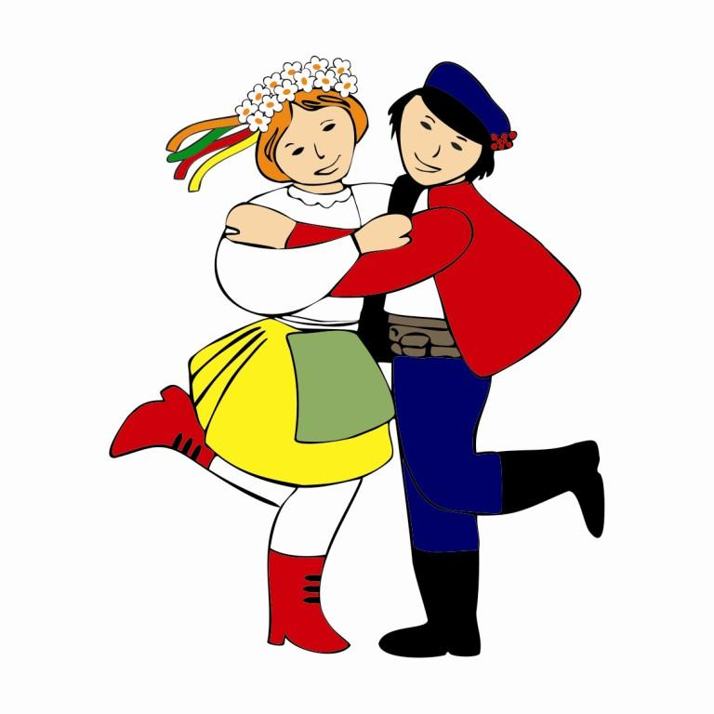
9th International Festival „Folklore of the World”
Zduńska Wola, 29 June - 01 July 2018

Registration Card

- Group’s name: _________________________________________________________________________

Address: _____________________________________________________________________________

Phone: _______________________________ e-mail: ___________________________________________

- Group’s leader name: ____________________________________________________________________

Phone:____________________________ e-mail: ______________________________________________

Choreographer’s name: _______________________________________________________________

- Total number of group members:
All members: _____________ including: band, dancers, singers, group supervisors, drivers, companions etc.

Band:____________________________
Drivers:__________________________
Group supervisors:_________________
Companions:______________________

- Repertoire (title, music author, text author, duration):
A/
______________________________________________________________________________________
In case of a big ammount of groups only „A” will be qualified for presentation

B/
_______________________________________________________________________________________

- Accopaniment:
Band (how many members, what instruments)___________________________________________________
_______________________________________________________________________________________
Record: CD _____________________________________________________________________________

- Invoicing data:
(Invoicings will be available in festival’s office)
_______________________________________________________________________________________

_______________________________________________________________________________________

7. Technical requirements:_________________________________________________________________
______________________________________________________________________________________

8. Stay in Zduńska Wola:

Arrive: 29.06.2018 before 12 p.m.
Departure: 01.07.2018 after the Main Concert
Another date: __________________________________

9. Group supervisor/leader statement:

Name and surname:__________________________________________________________________________

Address:___________________________________________________________________________________

ID number:_________________________________________________________________________________

I claim that I am the supervisor of the group participating in the 9th International Festival “Folklore of the World”.
Name of the group___________________________________________________________________________
Number of members__________________________________________________________________________

I take full responsibility for security and every activity of our members during the festival.
In order to take the whole responsibility for life and health of our members I am obliged to take care, constant observe and supervise all the members of our group for the whole time of staying in Culture, Sport and Recreation Centre in Zduńska Wola and also during events and excursions organized at the festival. I agree to pay a deposit for each member of a group

I claim that health condition of our members allows them to participate in the festival.

I claim that we are financially responsible for every damage caused by members of our group.

Date and signature
_____________________________

10. Authorization

We authorize ________________________________________________________ to represent our
group____________________________________________________________________ and to collect a financial reward in the 9th International Festival „Folklore of the World” (1.07.2018r.) in Zduńska Wola.

 | Group member (name and surname) | Pesel number | Signature
1.
2.
3.
4.

Delegating institution: Group supervisor / leader:

________________________
(date)

